**Logical reasoning (set 2)**

**Company name: Tata consultancy services No. of Question: 16**

**1. Directions:** Find the missing number:

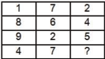

1. 9
2. 10
3. 11
4. 12

**Answer:** option c

**Solution :**

1 + 8 + 9 + 4 = 22

7 + 6 + 2 + 7 = 22

2 + 4 + 5 + 11 = 22

**2. Directions:** Find the mirror image of the figure given below.

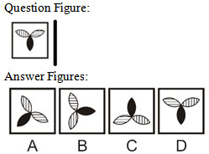

1. A
2. B
3. C
4. D

**Answer:** option d

**Solution :**

Answer Figure (d) is the correct mirror image of the question figure.

**3. Directions:** In a certain code language, ‘-’ represents ‘×’, ‘÷’ represents ‘+’, ‘+’ represents ‘÷’ and ‘×’ represents ‘-’. Find out the answer to the following question.

160 + 8 × 30 ÷ 4 – 6 = ?

1. 42
2. 14
3. 5
4. 17

**Answer:** option b

**Solution :**

160 ÷ 8 – 30 + 4 × 6 = 14

**4. Directions:** Which answer figure will complete the pattern in the question figure.

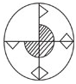

1. 
2. 
3. 
4. 

**Answer:** option b

**Solution :**

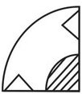

**5. Directions:** Find the number of triangles in the below figure?

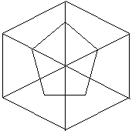

1. 12
2. 11
3. 10
4. 9

**Answer:** option c

**Solution :**

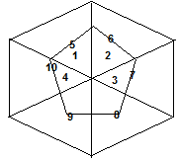

**6. Directions:** The figure given on the left-hand side in each of the following questions is folded to form a box. Choose from the alternatives (1), (2), (3) and (4) the boxes that is similar to the box formed.

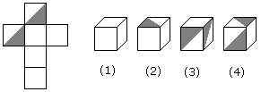

1. 1, 2 and 4 only
2. 3 and 4 only
3. 1 and 2 only
4. 1, 2 and 3 only

**Answer:** option a

**Solution :**

Only dice 1, 2 and 4 can be formed out of the given dice.

**7. Directions:** Three of the following four are alike in certain way and so form a group. Which is the one that does not belong to that group?

1. Yajur veda
2. Atharva veda
3. Rig veda
4. Ayurveda

**Answer:** option d

**Solution :**

Except Ayurveda, all others are Vedas. ‘Ayurveda’ is the branch of medicine.

**8. Directions:**A ranks fifth in a class. B is eighth from the last. If C is sixth after A and just in the middle of A and B, then how many students are there in the class?

1. 23
2. 24
3. 25
4. 26

**Answer:** option b

**Solution :**

Here, the position of B from the top=11 × 2-5=17th

Whereas, the position of B from the last =8th (given)

thus the total number of students in the class =17+8-1=24

**9. Directions:** which value will come in the place of question mark (?).

6, 24, 60, 120, 210, 336, ?, 720

1. 511
2. 421
3. 481
4. 504

**Answer:** option d

**Solution :**

23 – 2 = 6

33 – 3 = 24

43 – 4 = 60

53 – 5 = 120

63 – 6 = 210

73 – 7 = 336

83 – 8 = 504

93 – 9 =720

**10. Directions:** In the following question, four words have been given, out of which three are

alike in some manner, while fourth is different. Choose the odd one out.

1. 24
2. 6
3. 30
4. 120

**Answer:** option d

**Solution :**

6 = 1*2*3, 24 = 2*3*4, 120 = 4*5*6

**11. Directions:**In the following below are given three statements followed by three conclusions numbered I, II and III. You have to take the given statements to be true even if they seem to be at variance from commonly known facts and decide which of the given conclusion logically follows form the four given statements.

**Statements**:

All kids like to play.

Some kids like ice-cream.

Some kids look like their mothers.

**Conclusions**:

I. All kids who like ice-cream look like their mothers.

II. Some Kids who like ice-cream also like to play.

III. Kids who like to play do not look like their mothers.

1. Only I
2. Only II
3. Only II and III
4. None follow

**Answer:** option b

**Solution :**

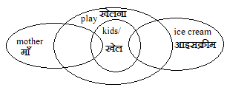

It is clear from the above mentioned venn diagram that some children prefer ice cream and some children Looks like their mother only, while conclusion I talked about all the escapes Therefore, the conclusion I is not correct While according to Conclusion II, some children who like ice cream also like to play, therefore Conclusion II is right.

And some children who look like their mother also like to play, Whereas Conclusion III is the opposite so the conclusions III will not be correct

**12. Directions:** Which one set of letters when sequentially placed at the gaps in the given

Letter series shall Complete it?

a_n_b_ _ncb_ _ncb

1. bcabab
2. bacbab
3. abcbcb
4. abbbcc

**Answer:** option a

**Solution :**



**13. Directions:**Find the figure out of the answer choices figures that can be formed by joining the pieces given in the question figure.

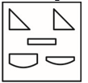

1. 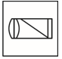
2. 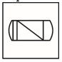
3. 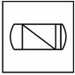
4. 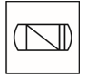

**Answer:** option d

**Solution :**

Option figure (d) is correct answer.

**14. Directions:**If in a certain code language ‘POT’ is written as ‘151714161921’, ‘TIN’ is

written as ‘19218101315’, then how will ‘DO’ be written in that language?

1. 351416
2. 534161
3. 351476
4. 351461

**Answer:** option a

**Solution :**

Each letter is coded with its left and right letters positions.

P O T

15 17 14 16 19 21

T I N

19 21 8 10 13 15

Hence,

D O

3 5 14 16

**15. Directions:** In the following question find the missing number that will complete the

series.

3, 2, 8, ?, 13, 22, 18, 32, 23, 42.

80

12

32

24

**Answer:** option b

**Solution :**

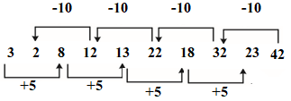

**16. Directions:** Arrange the given words in the sequence in which they occur in dictionary?

1. Lazily

2. Liquid

3. Luxury

4. Lockup

1. 2134
2. 1243
3. 2431
4. 2341

**Answer:** option b

**Solution :**

According to dictionary,

1. Lazily

2. Liquid

4. Lockup

3. Luxury